PR_1

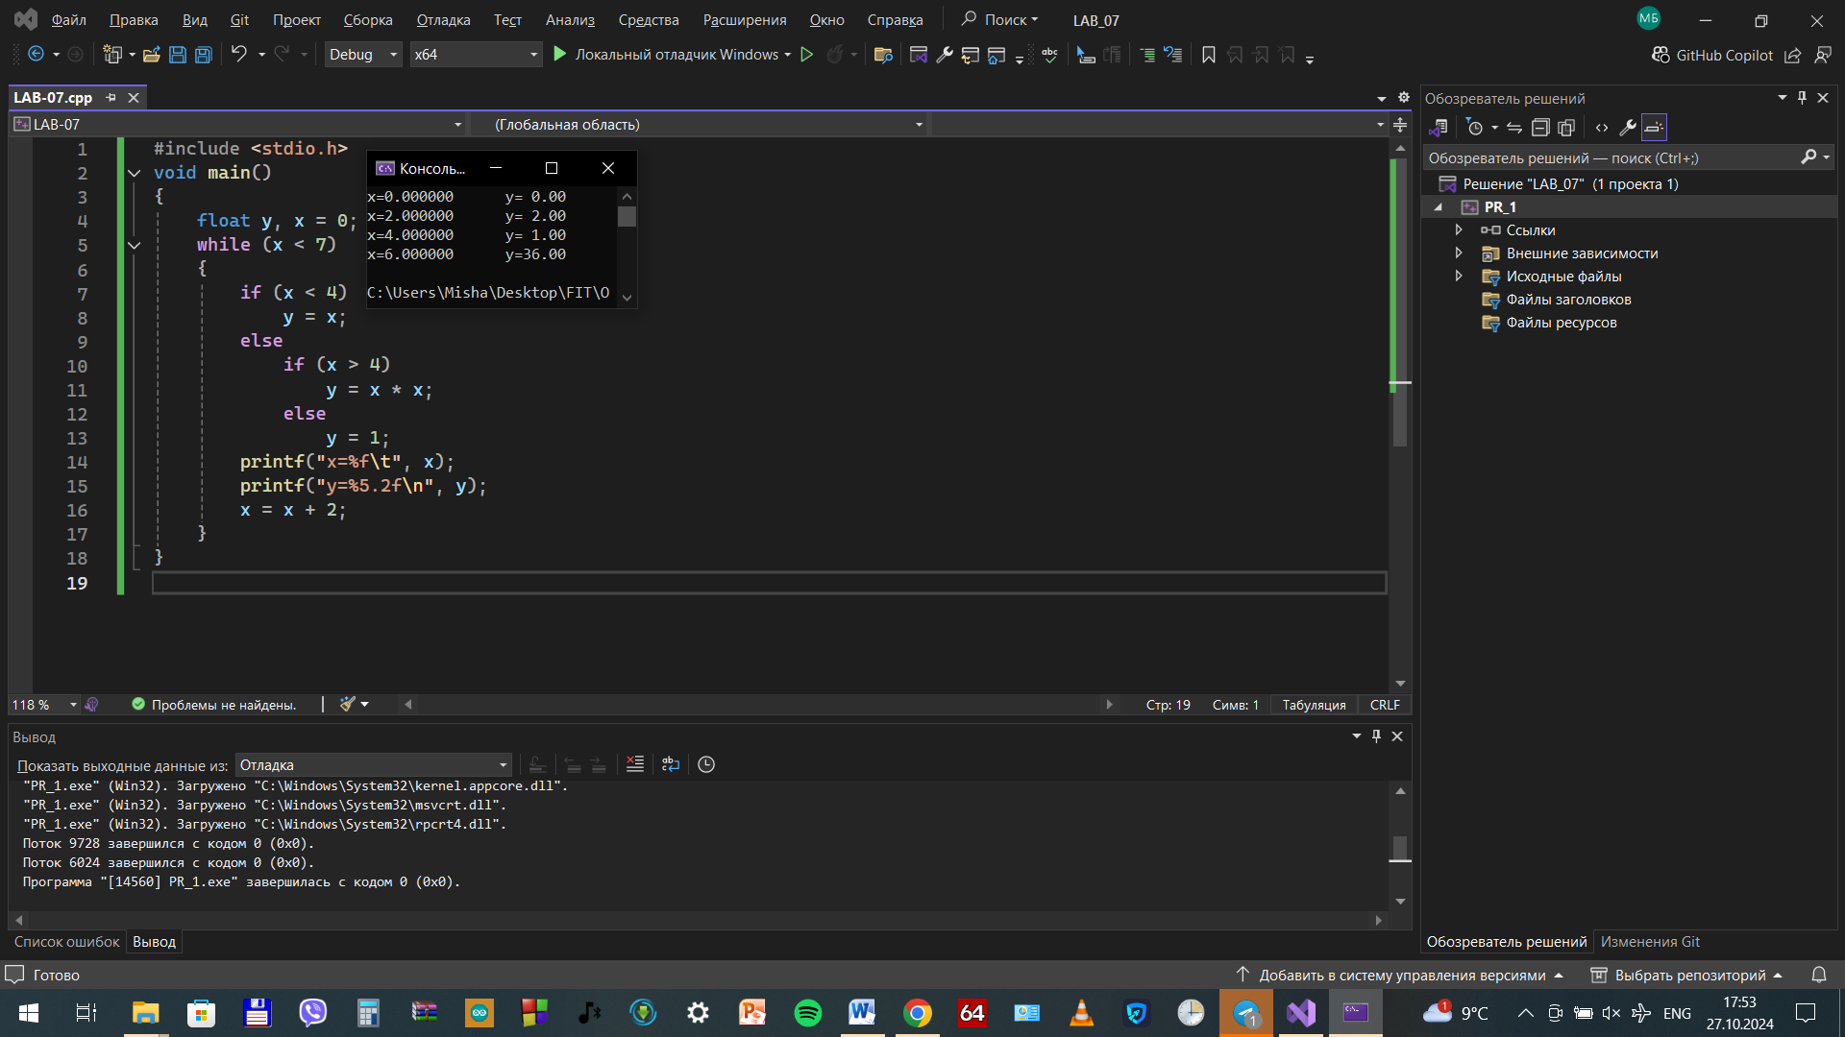Пример 2

**#include <iostream>**

**using namespace std;**

**void main()**

**{**

**float z, y, x = 3;**

**while (x < 4.1)**

**{**

**z = 2 * pow(x, 2);**

**y = z + pow(x, (float)1 / 3);**

**cout << "x=" << x << "\t";**

**cout << " y=" << y << endl;**

**x = x + 0.1;**

**}**

**}**

Запись прокрутки

X=3

3<=4.1; z = 2 * pow(x, 2); y = z + pow(x, (float)1 / 3);вывод x=3 и y=19.4422

X=x+0.1

X=3.1

3.1<=4.1; z = 2 * pow(x, 2); y = z + pow(x, (float)1 / 3);вывод x=3.1 y=20.6781

X=x+0.1

X=3.2

3.2<=4.1; z = 2 * pow(x, 2); y = z + pow(x, (float)1 / 3);вывод x=3.2 y=21.9536

X=x+0.1

X=3.3

3.3<=4.1; z = 2 * pow(x, 2); y = z + pow(x, (float)1 / 3);вывод x=3.3 y=23.2688

X=x+0.1

X=3.4

3.4<=4.1; z = 2 * pow(x, 2); y = z + pow(x, (float)1 / 3);вывод x=3.4 y=24.6237X=x+0.1

X=3.5

3.5<=4.1; z = 2 * pow(x, 2); y = z + pow(x, (float)1 / 3);вывод x=3.5 y=26.0183 X=x+0.1

X=3.6

3.6<=4.1; z = 2 * pow(x, 2); y = z + pow(x, (float)1 / 3);вывод x=3.6 y=27.4526X=x+0.1

X=3.7

3.7<=4.1; z = 2 * pow(x, 2); y = z + pow(x, (float)1 / 3); x=3.7 y=28.9267X=x+0.1

X=3.8

3.8<=4.1; z = 2 * pow(x, 2); y = z + pow(x, (float)1 / 3);вывод x=3.8 y=30.4405

X=x+0.1

X=3.9

3.9<=4.1; z = 2 * pow(x, 2); y = z + pow(x, (float)1 / 3);вывод x=3.9 y=31.994X=x+0.1

X=4

4<=4.1; z = 2 * pow(x, 2); y = z + pow(x, (float)1 / 3);вывод x=4 y=33.5874

X=x+0.1

X=4.1

4.1<=4.1; z = 2 * pow(x, 2); y = z + pow(x, (float)1 / 3);вывод x=4.1 y=35.2205X=x+0.1

X=4.2

4.2> 4.1; Выполнение программы закончено

PR_2

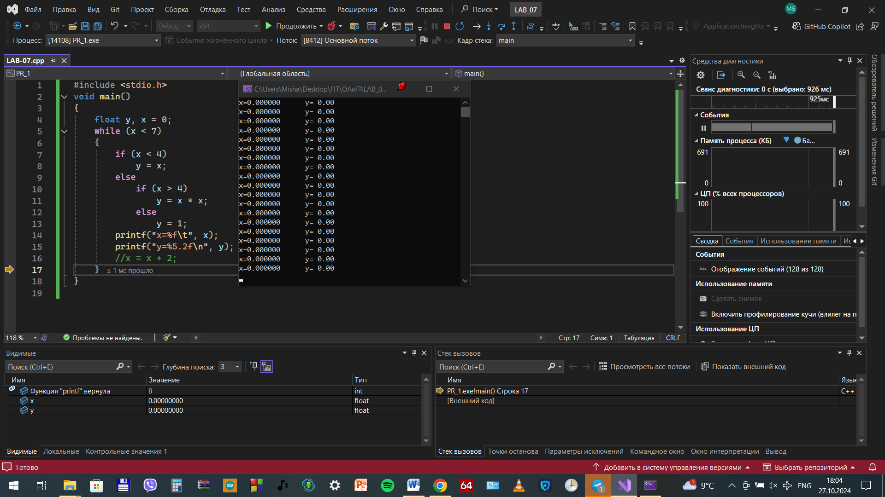

PR_4

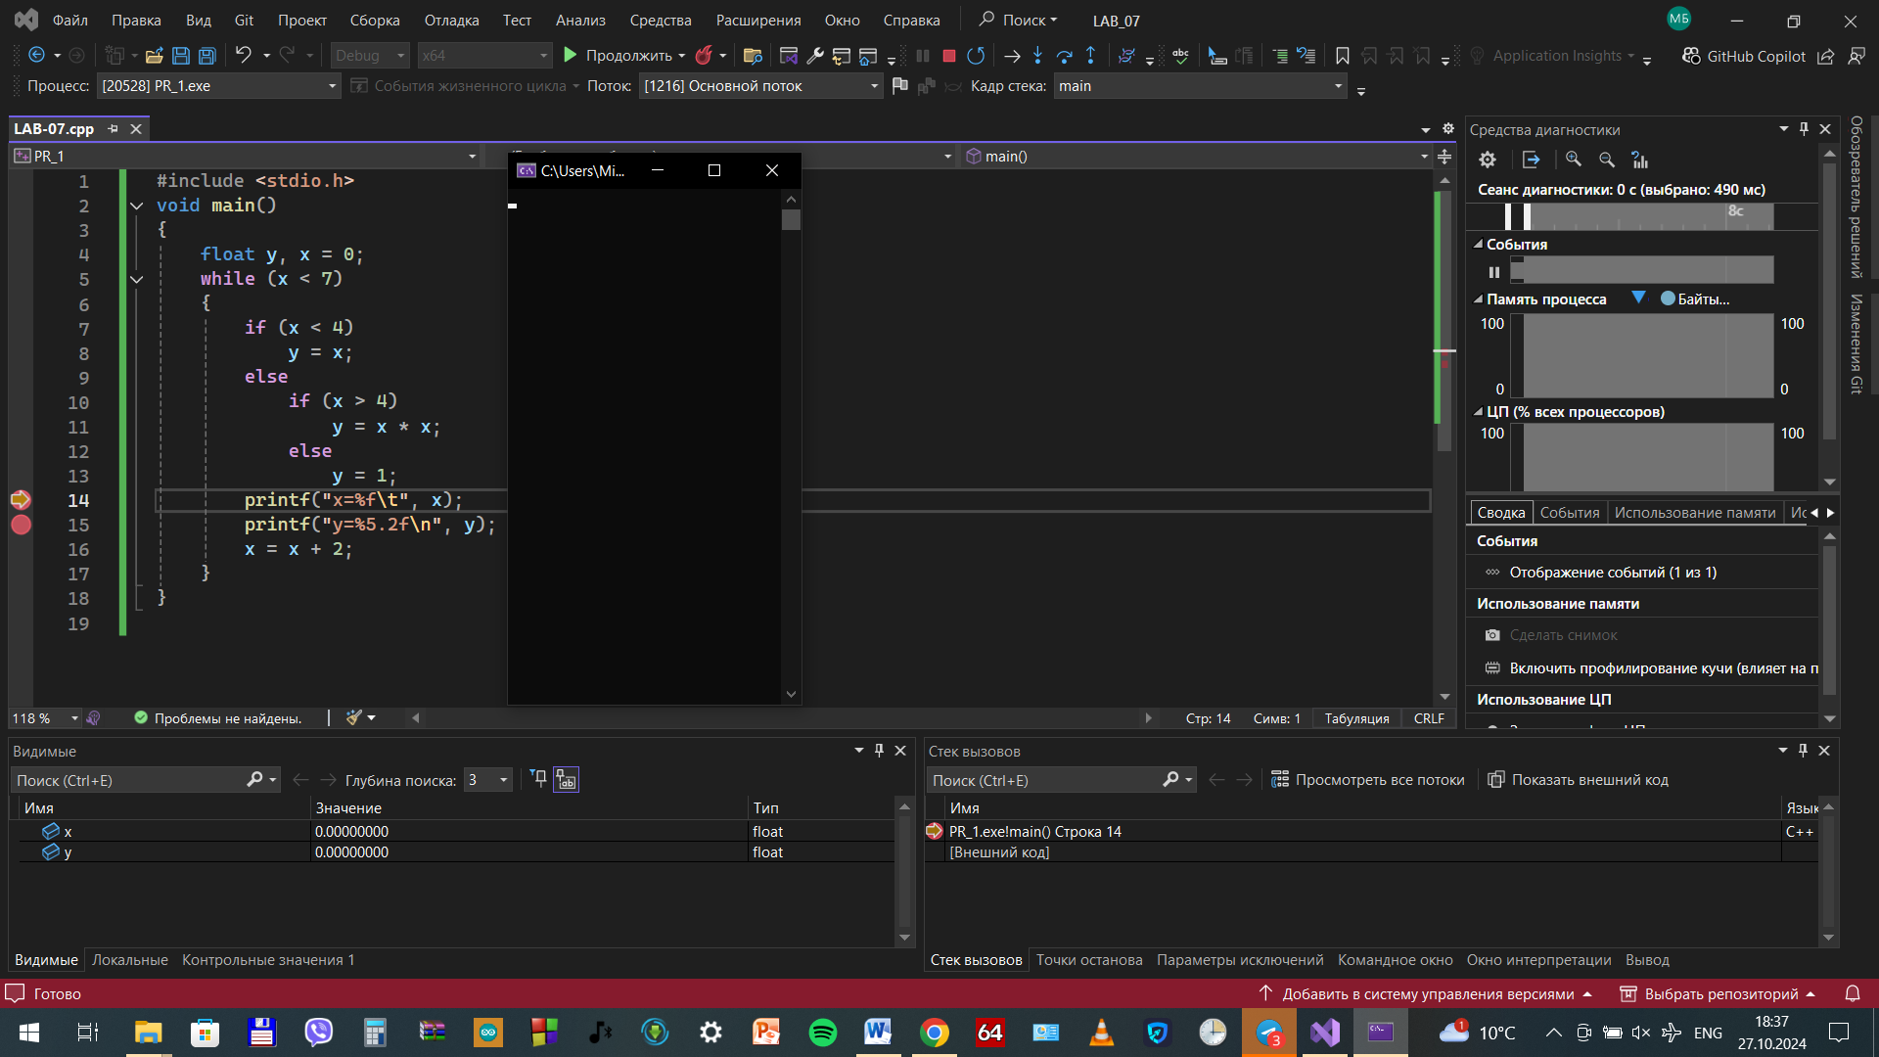

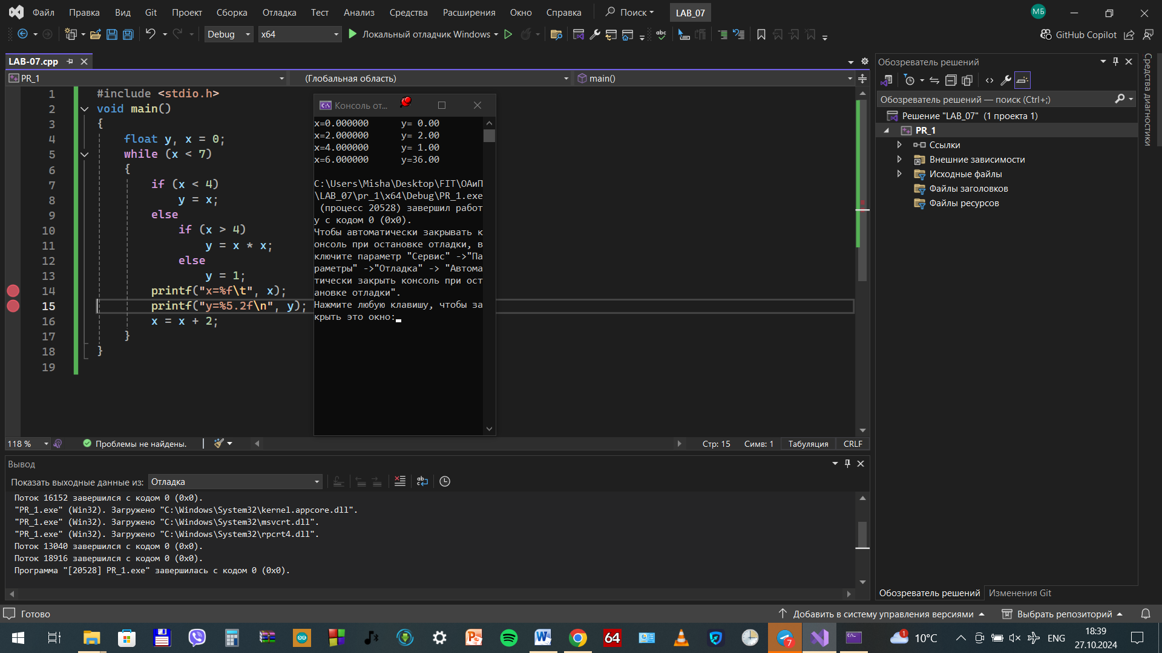

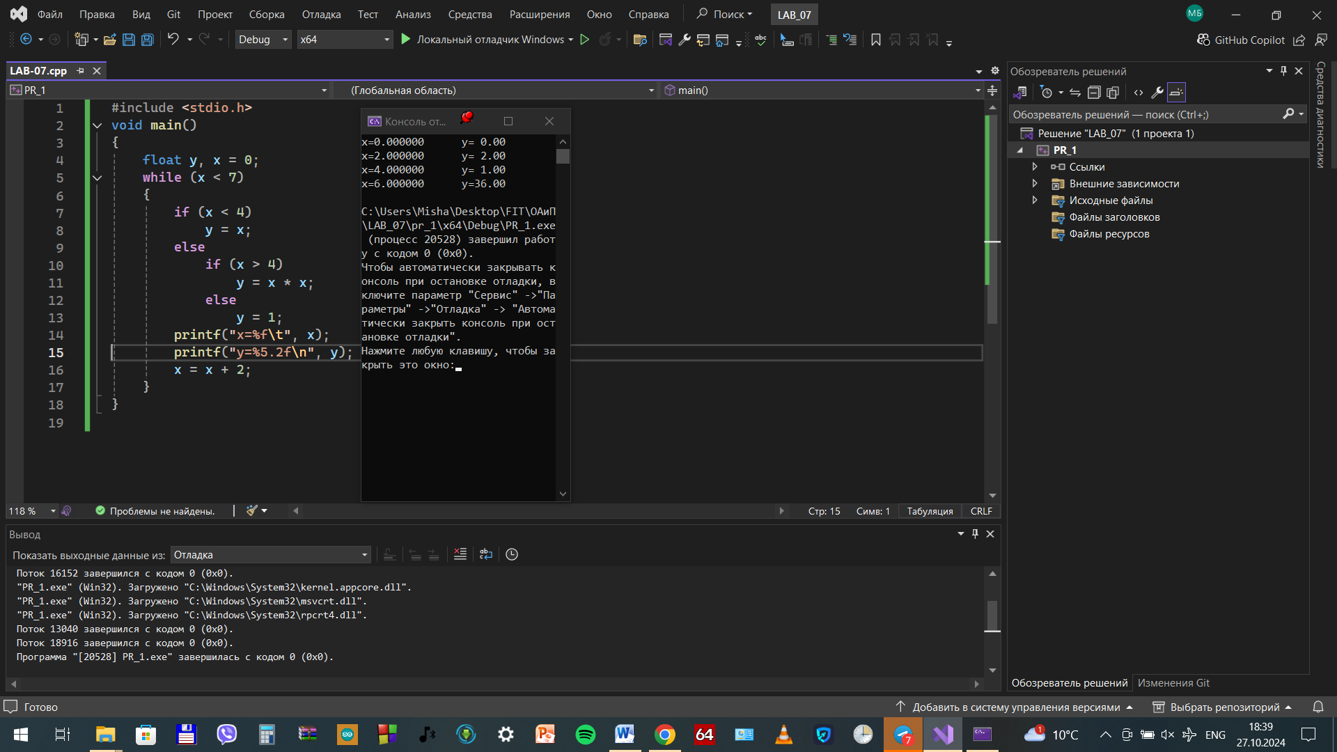

PR_5

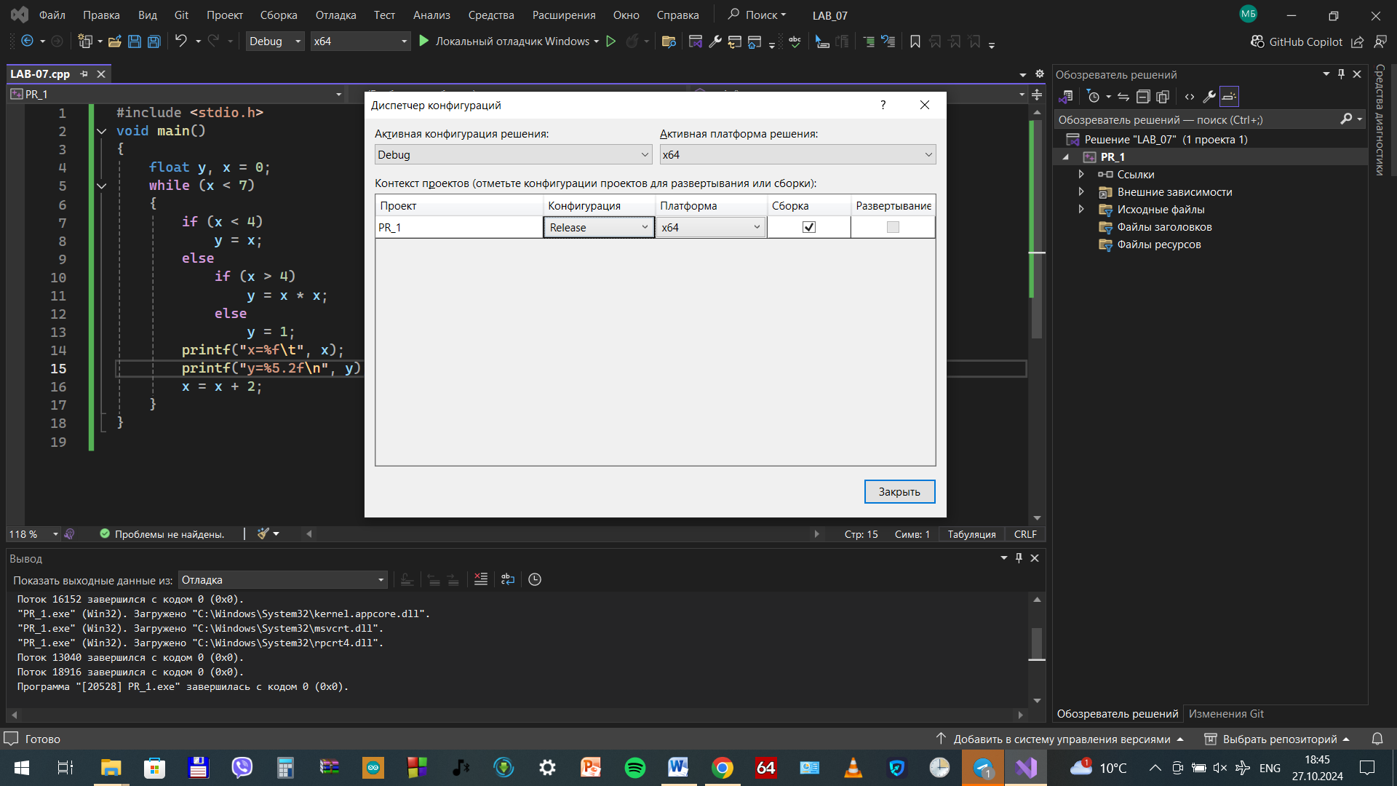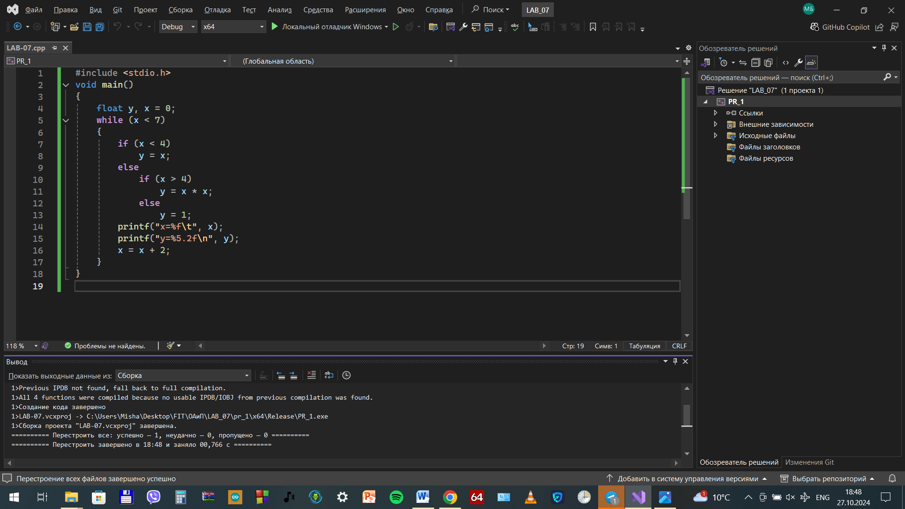

V3_6_1

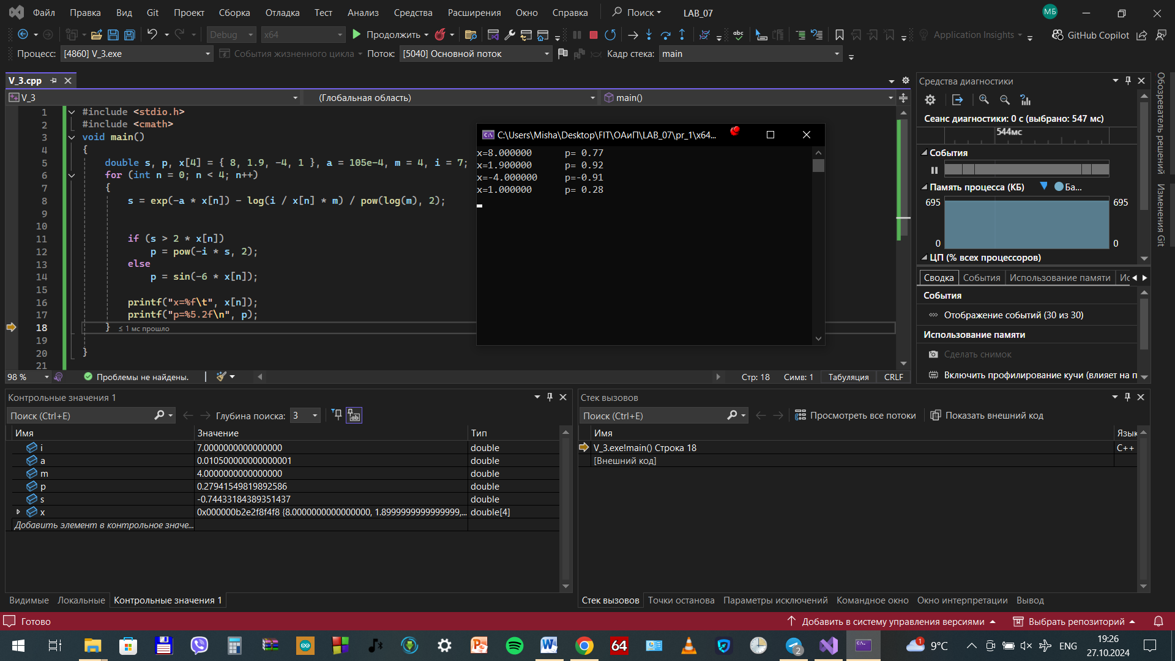



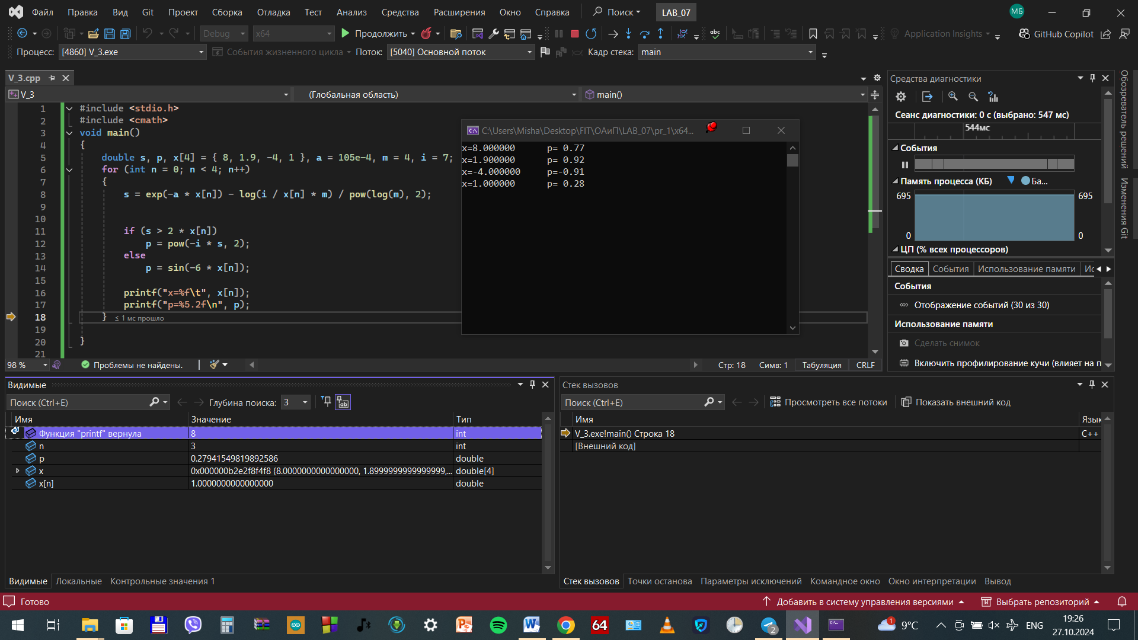

V3_6_2

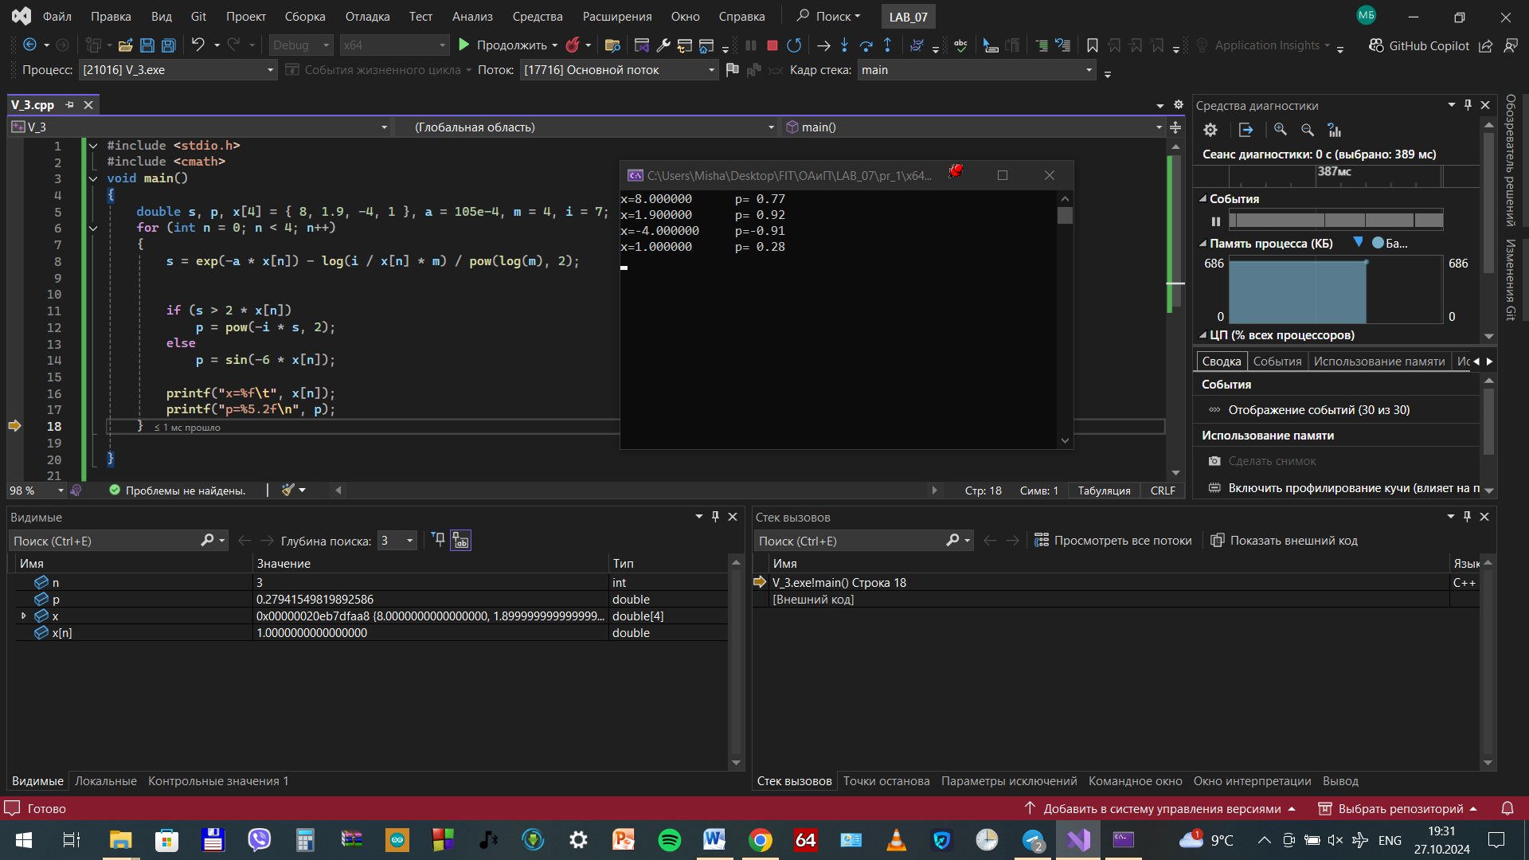

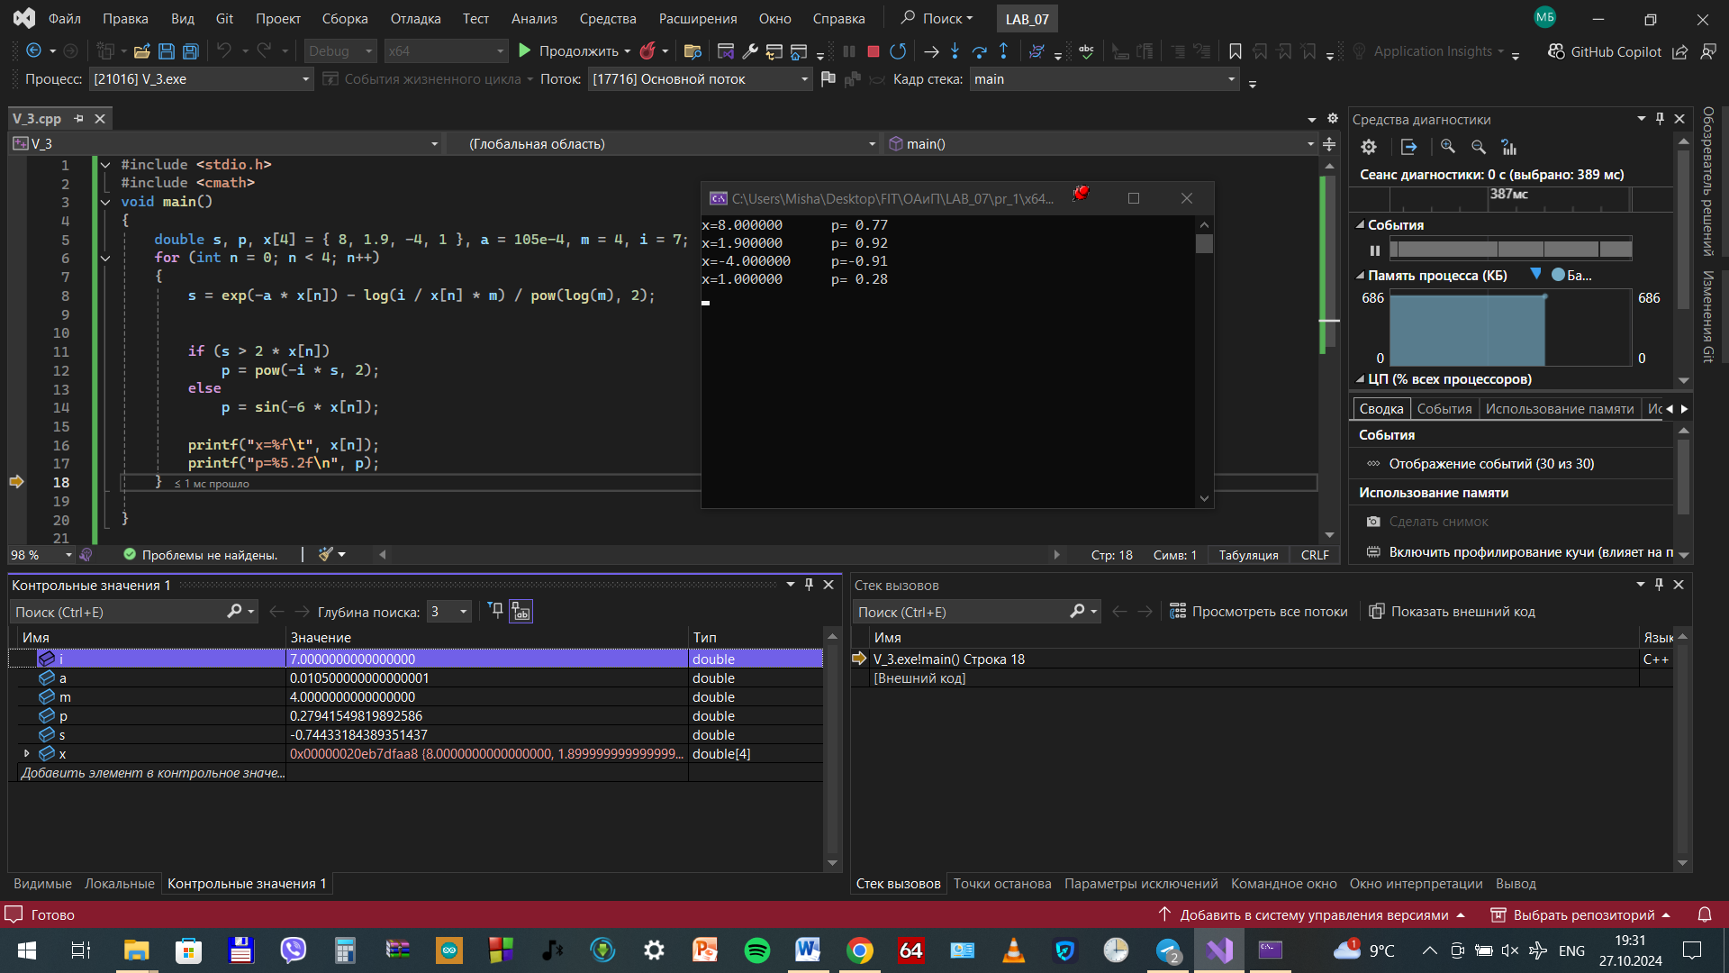

V3_7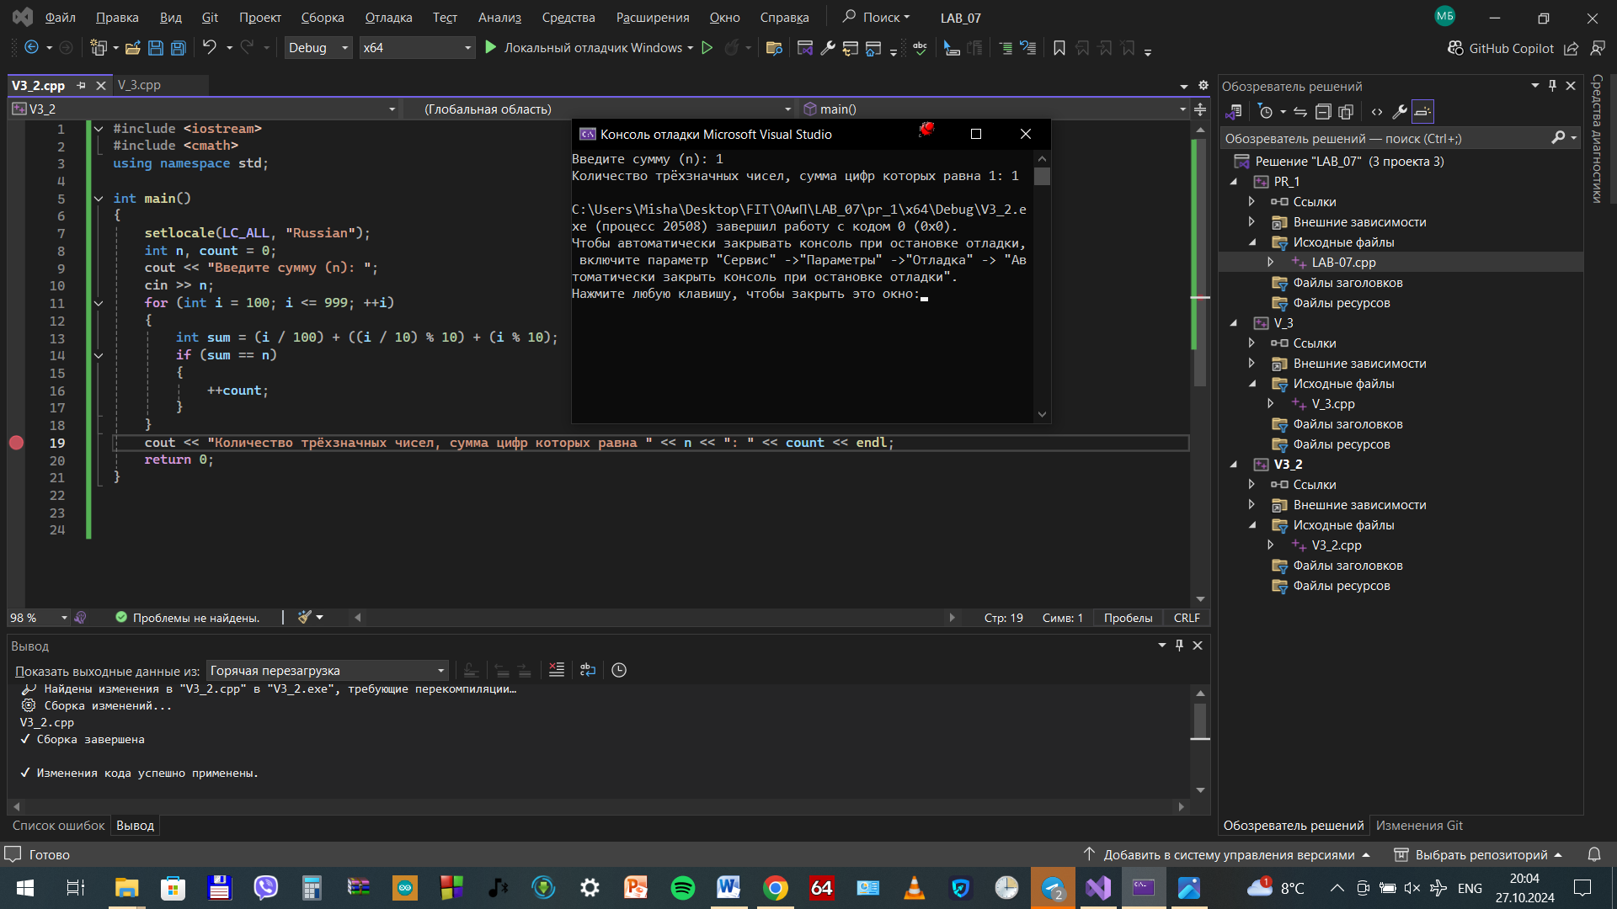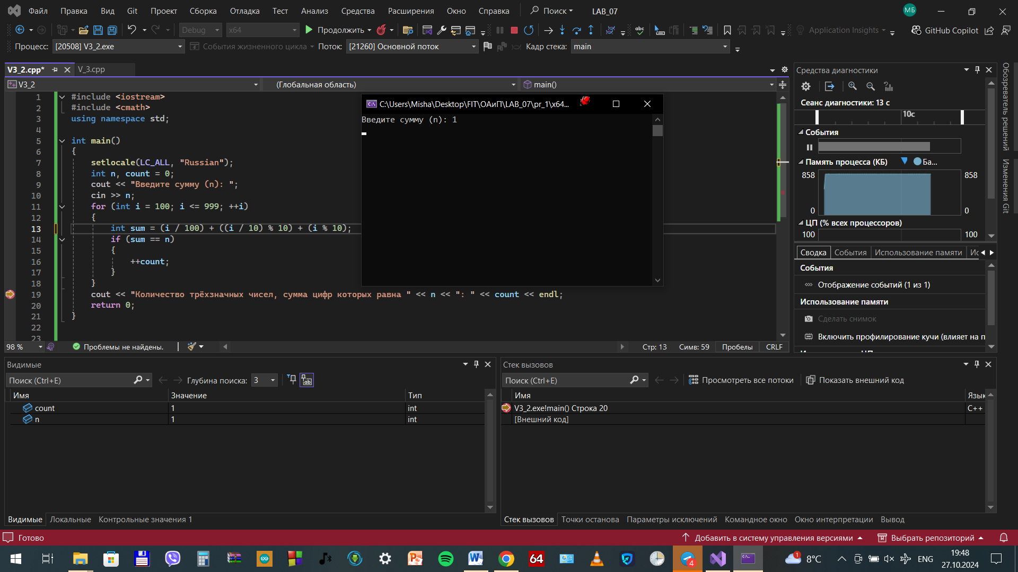

DOP_1_3

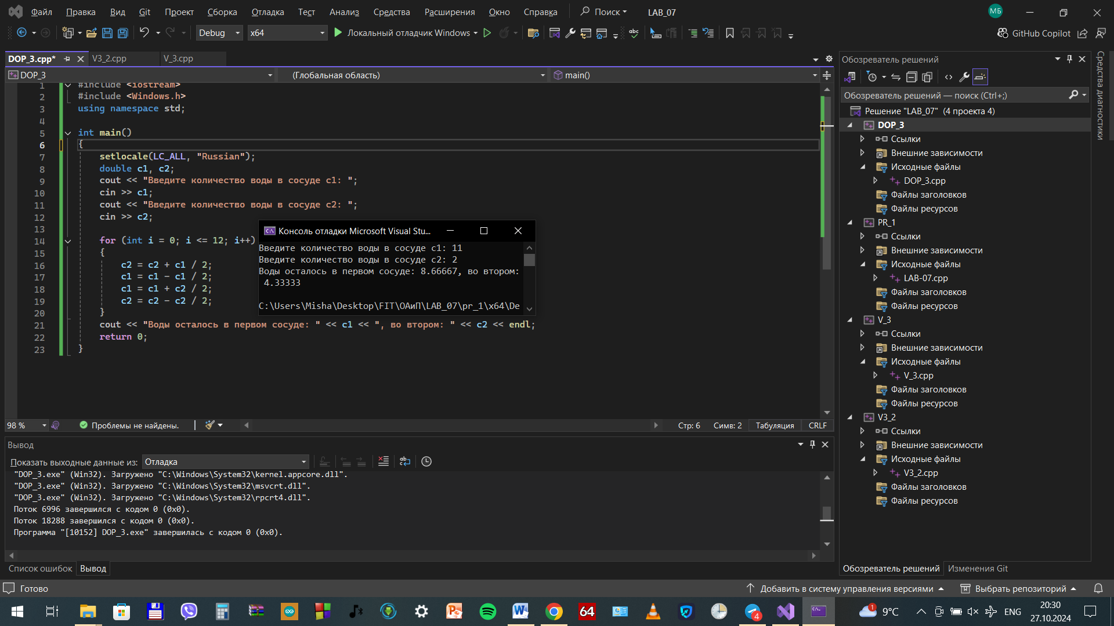

DOP_2_2